<page_start no = 1>
<sol_start id=1>
1. (4) Both (1) & (2)
<sol_end>

<sol_start id=2>
2. (2) Mitochondria only
<sol_end>

<sol_start id=3>
3. (1) RBC
<sol_end>

<sol_start id=4>
4. (2) Transpiration
<sol_end>

<sol_start id=5>
5. (4) (1) & (2)
<sol_end>

<sol_start id=6>
6. (4) None of these
<sol_end>
<page_end>

<page_start no = 2>
<sol_start id=7>
Respiration in plants |  | Respiration in animals
(i) | They do not breathe, they respire through their leaves. | (i) | They breathe air for respiration.
(ii) | Respiratory organs are absent. Respiration takes place through diffusion. | (ii) | Respiratory organs are present like lungs (in human), gills (in fishes) etc.
7.

<sol_end>

<sol_start id=8>
Light Reaction |  | Dark Reaction
(i) | It takes place in the grana part of the chloroplast. | (i) | It takes place in the stroma part of the chloroplast.
(ii) | It is a photochemical phase. | (ii) | It is a biochemical phase.
(iii) | The end products are ATP and NADPH. | (iii) | The end product is glucose.
8.

<sol_end>
<page_end>

<page_start no = 3>
<sol_start id=9>
<sub_id = 1>
9. (a) The enzyme pepsin released by stomach and the enzyme trypsin released by pancreas acts on protein.
<sub_id end>
<sub_id = 2>
(b) If oxygen is not available, pyrunate underg reduction and produces lactic acid.
<sub_id end>
<sol_end>

<sol_start id=10>
<sub_id = 1>
10. (a) Role of Hydrochloride acid in stomach :
(1) It kills the germs in the stomach.
(2) It creates an acidic medium for enzyme pepsin to actron protein activate.
<sub_id end>
<sub_id = 2>
(b) 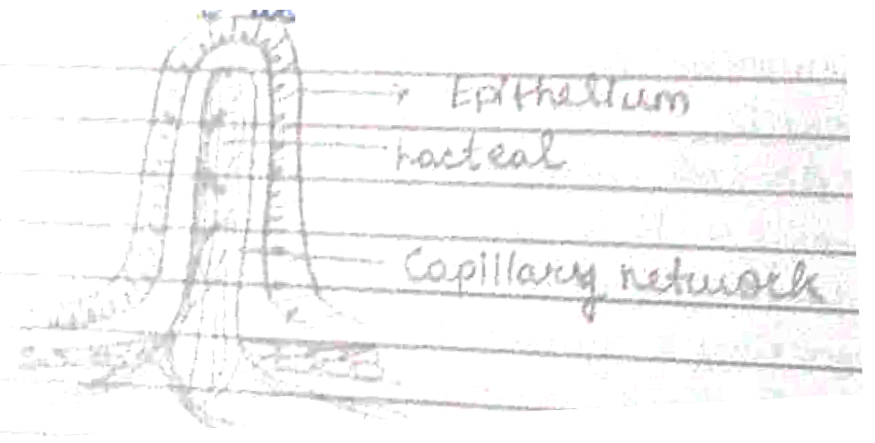
Function of lacteal – During the process of digestion, the lacteals absorb large molecules of fats and lipids from the small intestine.
<sub_id end>
<sol_end>

<sol_start id=11>
<sub_id = 1>
11. (a) Alveoli are covered with blood capillaries that the exchange of gases takes place between the membrane of alveoli and the surrounding capillaries. The blood capillaries covering alveoli have low oxygen and high CO₂ concentration. This allows O₂ to diffuse into the blood and CO₂ out of the blood.
<sub_id end>
<sub_id = 2>
(b) cartilaginous rings supports trachea and presents it from collapsing. It also helps in the flexible movement of nek during breathing.
<sub_id end>
<sol_end>
<page_end>

<page_start no = 4>
<sol_start id=12>
<sub_id = 1>
12. (a) During the winter season, the surrounding temperature is very low, so there is less sweating, thus no evaporation loses. Due to reason, we pass more urine in winter.
<sub_id end>
<sub_id = 2>
(b) The accessory excretory organs in humans are the urinary system (kidney, ureters, urinary bladder and urethra), skin lungs and liver.
<sub_id end>
<sub_id = 3>
(c) Excretory organs of arthropods are malphighian tubules and green gland.
<sub_id end>
<sol_end>

<sol_start id=13>
<sub_id = 1>
13. (i) 4 – left atrium
5 – right atrium
<sub_id end>
<sub_id = 2>
(ii) 3 and 6 are superior vena cava and inferior vena cava respectively. They bring the blood from various part of the body to the heart.
<sub_id end>
<sub_id = 3>
(iii) Arteries carry blood away from the heart.
<sub_id end>
<sub_id = 4>
(iv) The circulation in human beings is a double circulation because the blood passes the four chambered heart two times.
<sub_id end>
<sol_end>
<page_end>

